Exokeryx Inc.  
  
  
EXOPREP GUI USER GUIDE

Table of Contents

1 Welcome 2

2 Using the Instrument to Prepare your extracellular vesicles (EV) samples 3

2.1 Login Screen 3

2.2 Prepare Instrument 5

2.3 Method & Project Selection 6

2.4 Reagent Information 7

2.5 Cartridge Information 9

2.6 Sample Information 10

2.7 Confirm Page to Start 12

2.8 Method is now running 14

2.9 Method Completion 15

3 The Options Menu (Hamburger Menu) 15

3.1 Run History 17

3.2 Instrument Status Check 18

3.3 Instrument Sensors 19

3.4 Upgrading Software/Firmware of the Instrument 20

# Welcome

# Using the Instrument to Prepare your extracellular vesicles (EV) samples

In this section, we will go over the basic steps to preparing your EV samples using the ExoPrep step-by-step.

## Login Screen

The first screen when the ExoPrep desktop application starts with the Login Screen. This is where the various users (scientists, technicians, administrators) can login and access the instrument and the data associated with the user.

The management of the users in this list is shown in later chapter on “Managing User Access”.

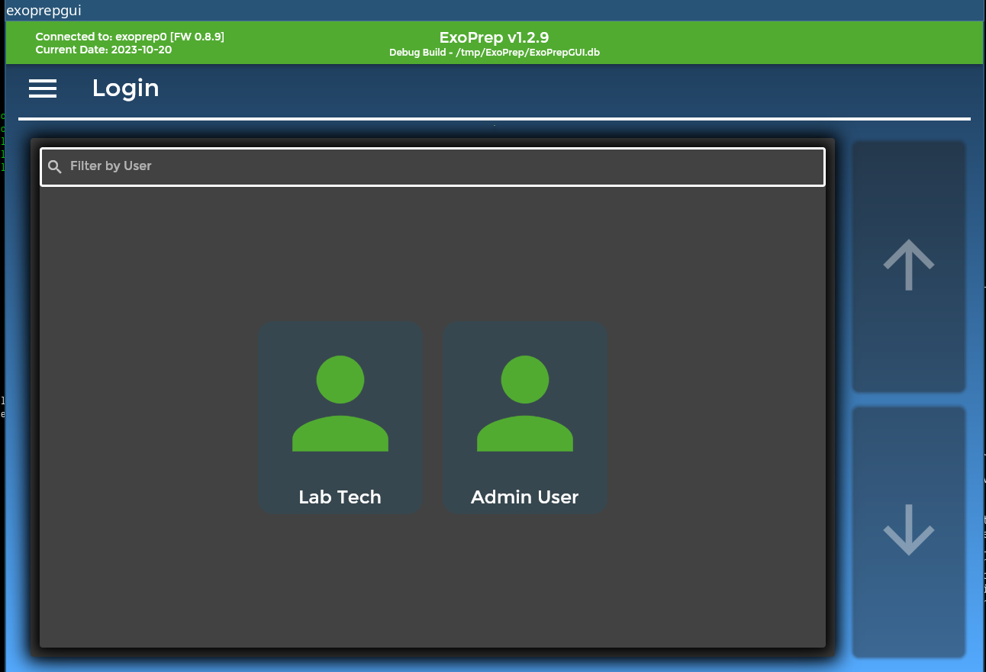

* Click or touch user icon to start.

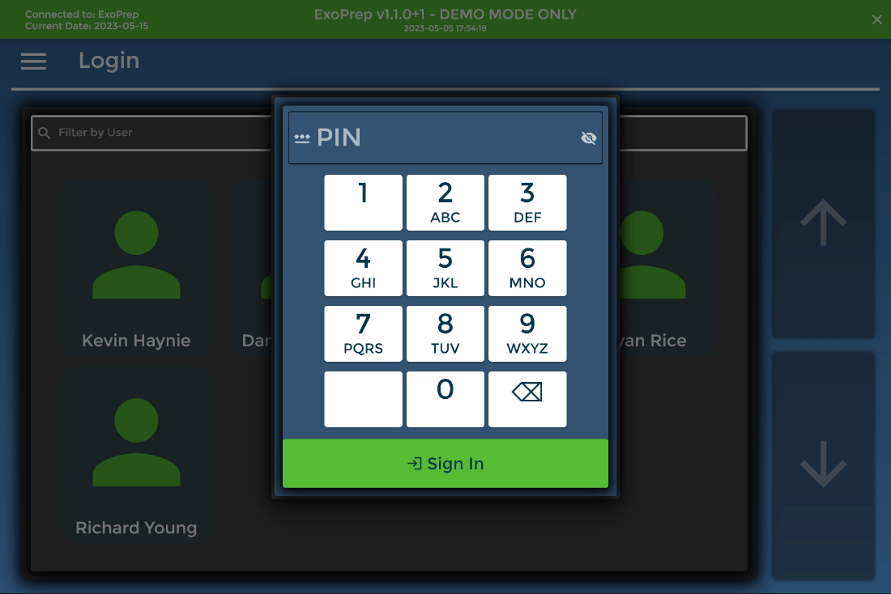

* All the PINs are set to 1234

## Prepare Instrument

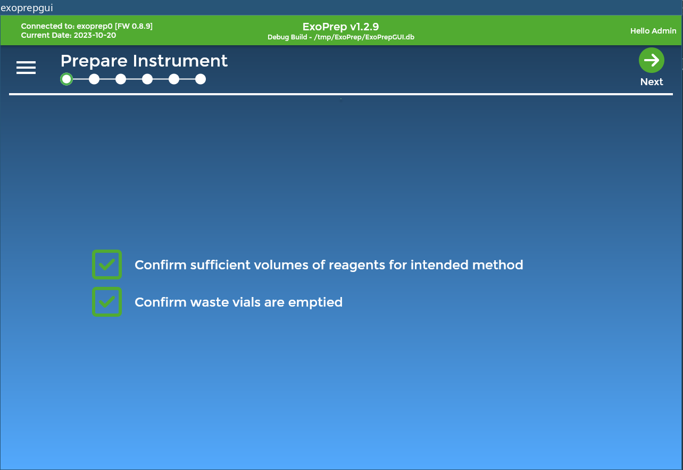

* The checkboxes can be turn into "Required" in settings to enforce user confirmation.

## Method & Project Selection

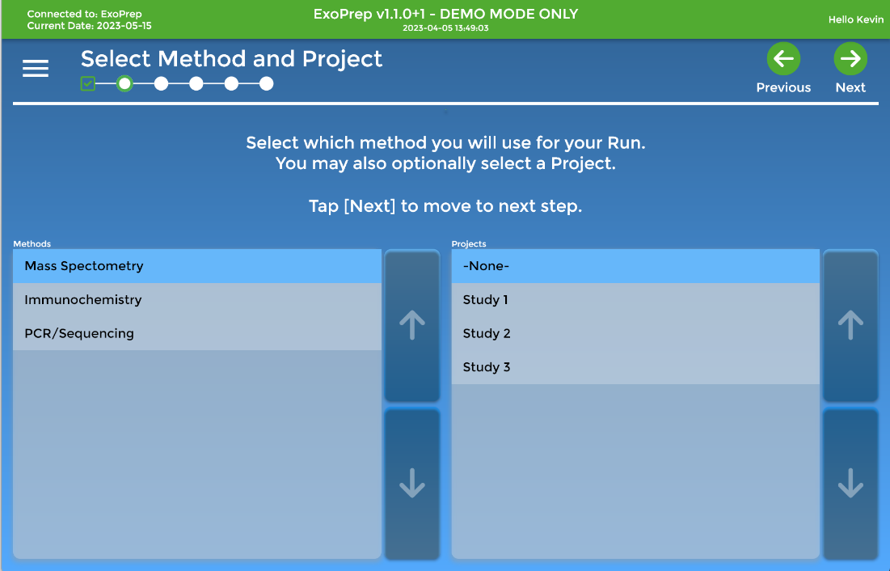

* For demo purposes, we will use the Mass Spectrometry.
* Project number can be of the available options.

## Reagent Information

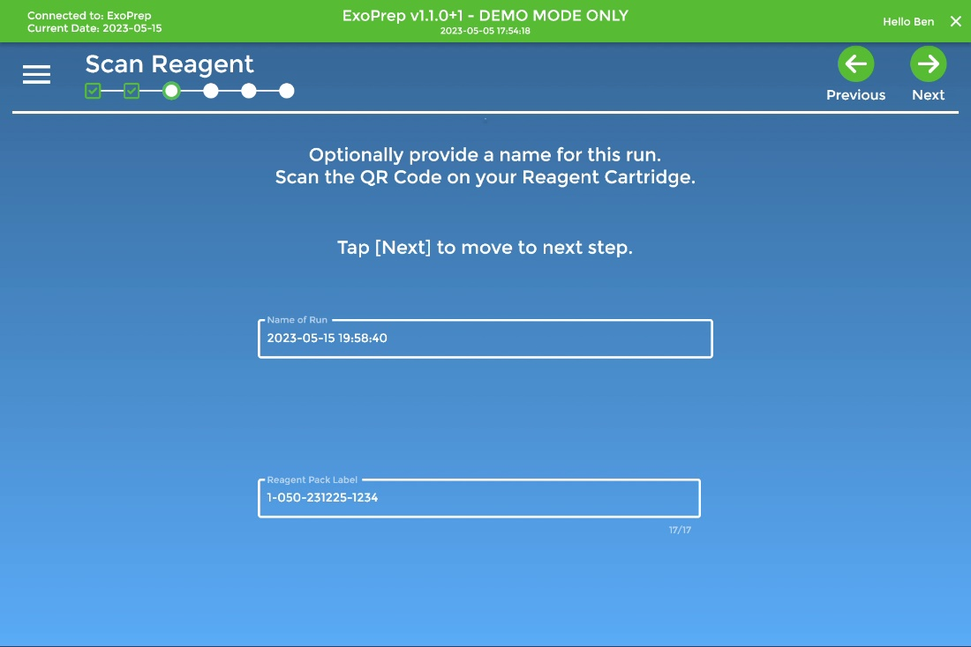

* The Reagent ID includes an expiration date to ensure methods are valid.
* The Reagent Pack QR code will be affixed to the Reagent Holder.
* Use the following barcode or QR code for the Mass Spec reagent pack.

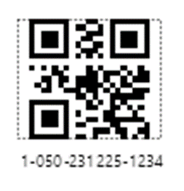

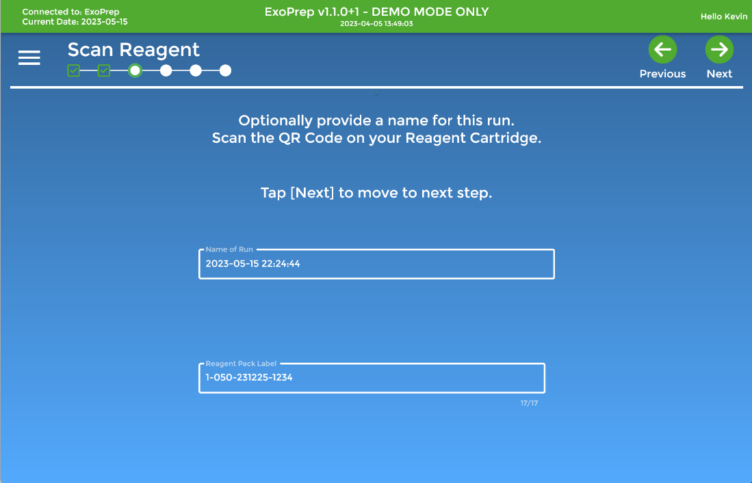

* In case of scanner not working, use the following Reagent ID:
  + 1-050-231225-1234
* Tap the text box to bring up virtual keyboard to enter.

## Cartridge Information

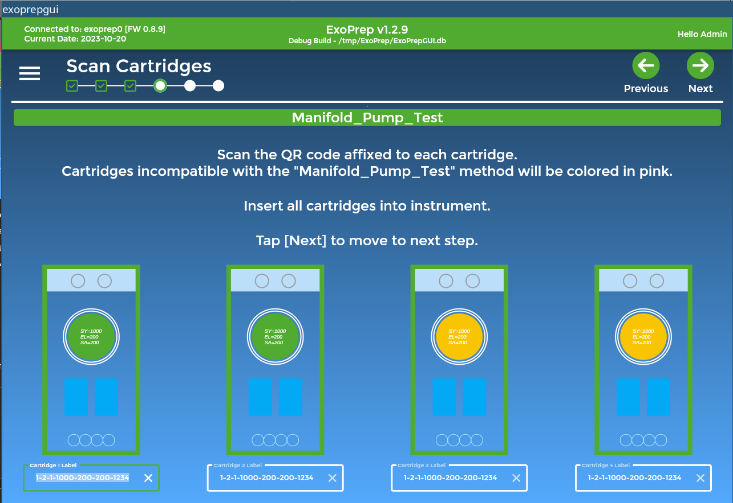

* This is where the user would scan each cartridge QR code and insert the cartridge, one by one, into the instrument.
* Each cartridge has a unique QR code label affixed to it.
* For demo, we will have use a single QR code for all 4 cartridges:

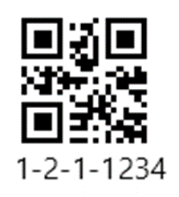

* Manual entry if needed:
  + 1-2-1-1234

## Sample Information

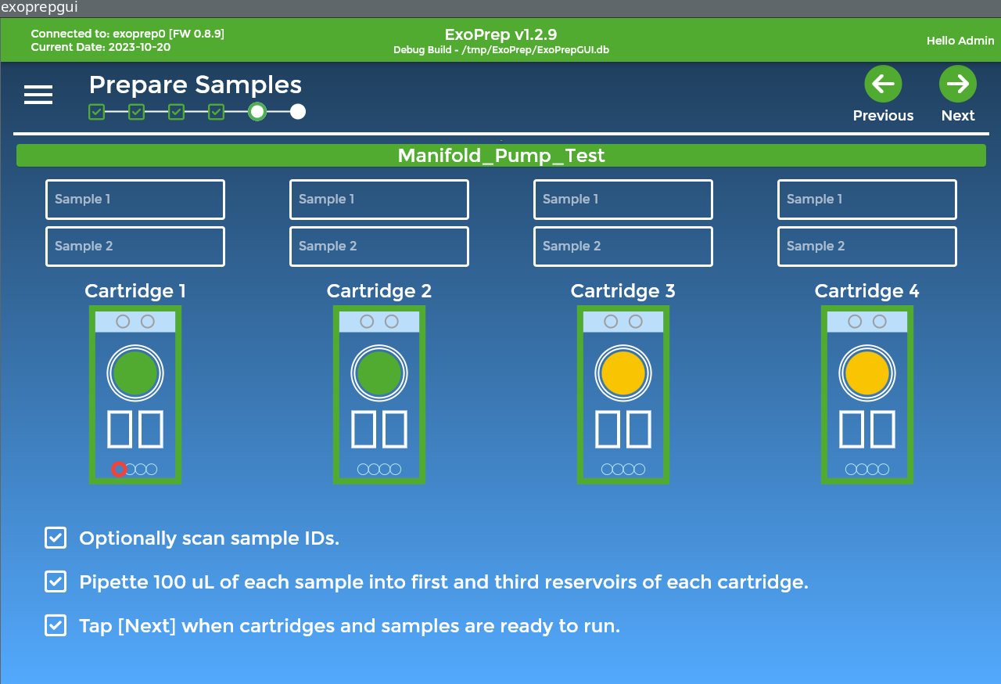

* Optionally allow users to enter information about the samples.
* Setting is available to require all sample labels to be scanned before moving to next page.
* Typically, samples will be bar coded or QR coded externally.
* For the sake of the demo, you can scan the following QR code or leave the samples blank:



* The sample ID can also be entered manually via the on screen keyboard:
  + PGX149602

## Confirm Page to Start

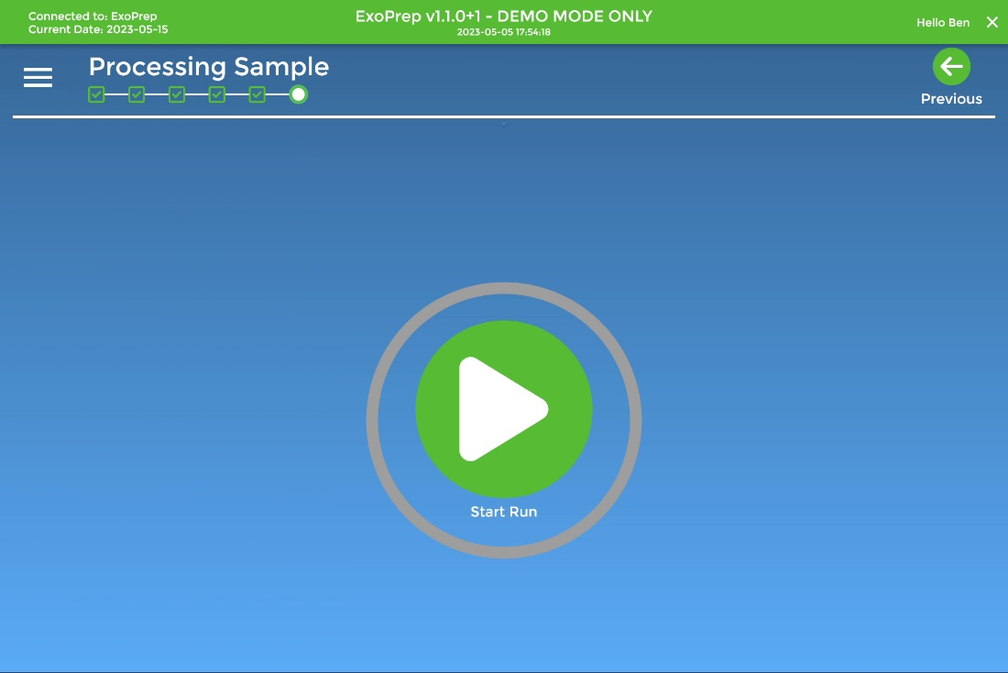

* Click the Green play button as final confirmation before starting.
* The steps in the selected method will then be run.
  + If in Demo Mode, no communication with the instrument will be attempted but each step will show for 2 seconds.

## Method is now running

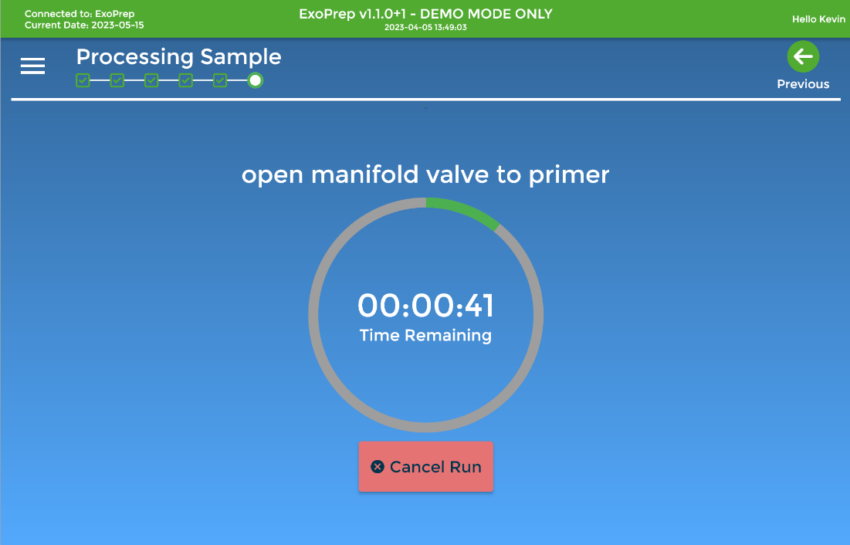

* Cancel Run: instrument will stop all activities, close all valves and return to a safe position for cartridge removal. Once user confirms removal, then we are allowed to start a new run.
* We do not allow pausing of methods since it would invalidate the method.
* Previous button on this screen is disabled once the run has begun.
* A notification email will be sent to the currently logged in user as soon as the last step is complete.
  + NOTE: You must set a valid email address in Settings|Users to receive emails.

## Method Completion

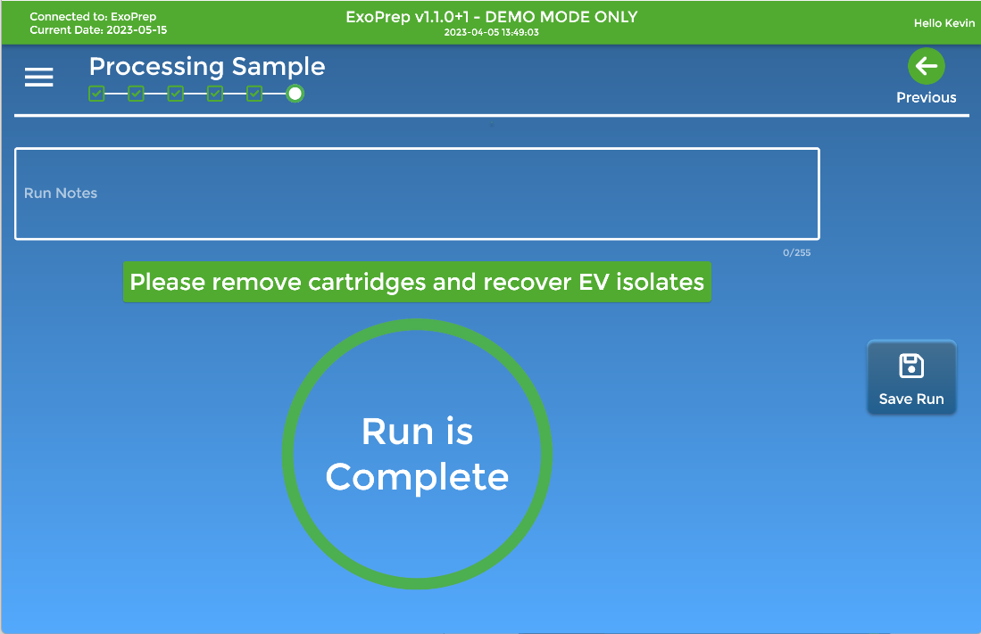

* At this screen, user can enter any information/metadata regarding this run and they will be captured in the built-in database.
* User can export the history/run notes at later time (e.g. import/connect to LIMS).
* Once the Run is Saved, we will go back to the Prepare Instrument page, ready for another run.

# The Options Menu (Hamburger Menu)

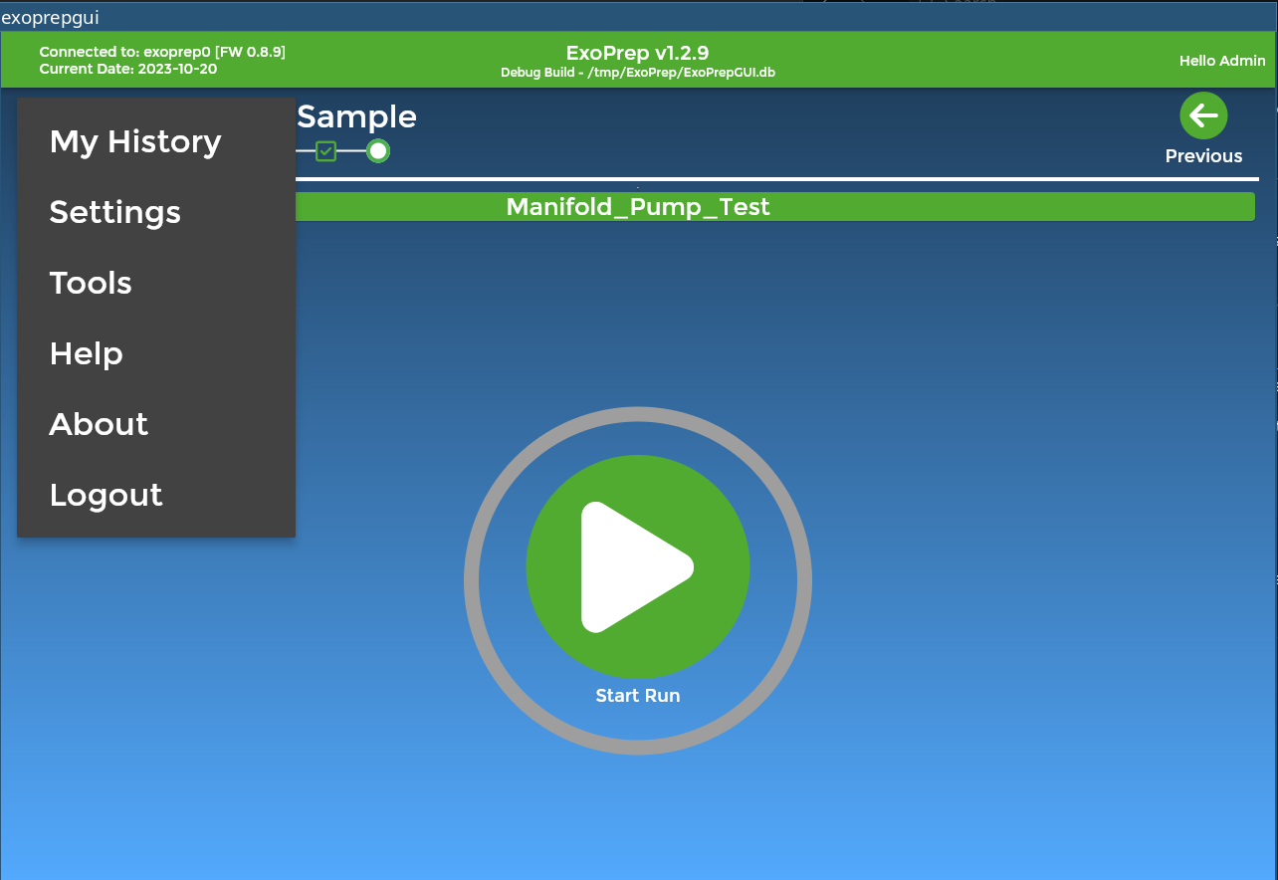

* Use this menu to access additional program options including settings and history
* Settings is where users and projects can be maintained, run defaults set, file locations specified, and software updates made

## Run History

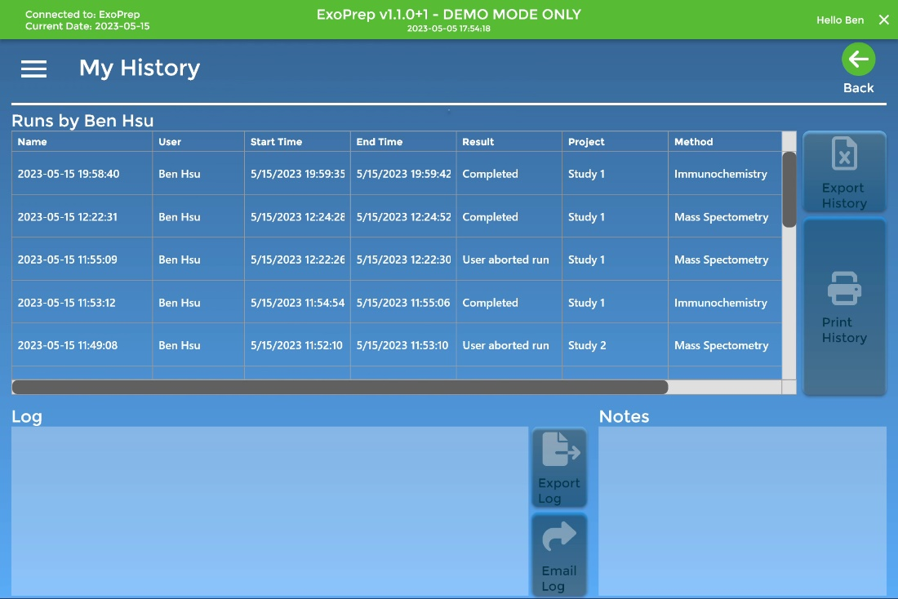

* We can see a list of previous runs by the current user.
* To see a list of all runs for all users, access this page *before* logging in.

## Instrument Status Check

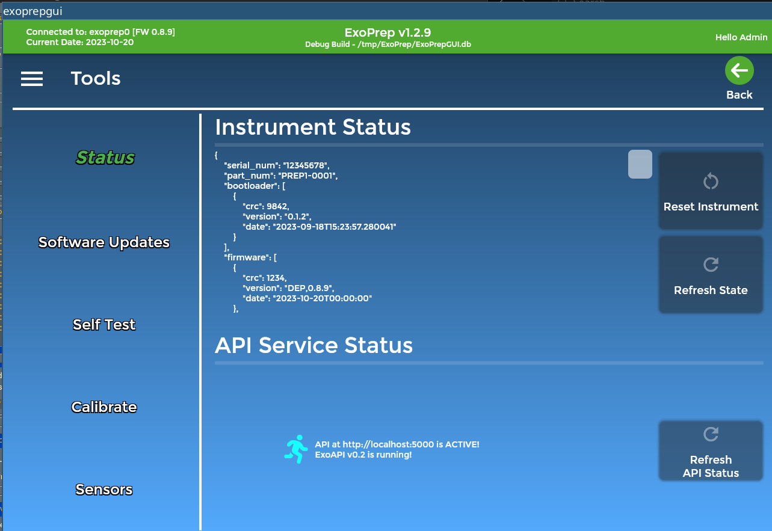

## Instrument Sensors

In order to facilitate any calibration and customer support, the PrepGUI also presents a set of tools/diagnostic screens that can be used to observe the current state of the instrument in the "Sensors" page.

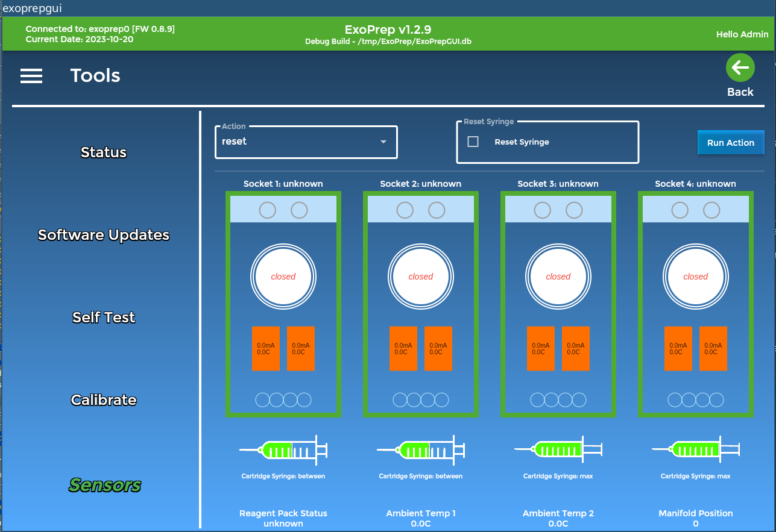

## Upgrading Software/Firmware of the Instrument

The Instrument contains both a desktop software component and a firmware component that executes on the instrument. From time to time, upgrading the firmware may be necessary for new features, improvements, and bug fixes. The upgrade process can be initiated in the Tools / Software Updates page.

